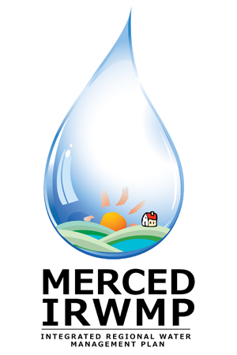

Merced Integrated Regional Water Management (IRWM) Plan
Regional Advisory Committee Meeting #2
Tuesday June 26, 2012
2:00 pm – 5:00 pm
The Sam Pipes Room
1st floor of the Civic Center (City Hall)
678 W. 18th Street
Merced, CA 95340

- Introductions 5 Min
- Approve Revised RAC Materials 20 Min
  - RAC Purpose and Charter
  - Governing Procedures
- Discuss Regional Overview 30 Min
  - Additional Documents to Review
  - Region Description
  - Relation to Local Water Planning
  - Relation to Local Land Use Planning
- Develop IRWM Plan Objectives 75 Min
  - Brainstorming Needs / Issues
  - Brainstorming Objectives
  - Prioritizing Objectives
- Discuss Disadvantaged Community (DAC) Outreach Approach 30 Min
  - Water Management Needs of DACs
  - Communities to target
  - Organizations to Contact
- Review Technical and Public Workshop Overview and Timing 10 Min
- Identify Next Steps 5 Min
- Public Comment 5 Min

